Amazon Customer Reviews Analytics & Sentiment Analysis

Introduction and Dataset Description

For this project, I selected the Amazon Reviews 2023 dataset, which contains customer product reviews across various product categories. The dataset includes attributes such as product ID (ASIN), user ID, rating, review text, timestamp, and verified purchase status.
The combination of structured and unstructured data makes this dataset an excellent candidate for both Data Analytics and Sentiment Analysis. I chose this dataset because e-commerce reviews are familiar and provide valuable opportunities to uncover customer behavior, purchasing patterns, and product performance through data-driven insights.

Data Collection and Ingestion

I initially attempted to access the dataset directly from AWS using Apache Spark. However, I encountered an HTTP 403 Unauthorized Access error, which prevented direct ingestion.
To overcome this limitation, I downloaded the dataset using Python and uploaded it to Databricks File System (DBFS). The dataset was stored in JSONL format, allowing Spark to efficiently read and process the data while complying with access restrictions.

Data Preparation
I performed several preprocessing steps to clean and standardize the dataset before analysis.
The timestamp column was converted into a standard date format to enable time-based analysis. Records containing missing values, such as ratings and product IDs, were removed, and duplicate records were eliminated to improve data quality.
I selected only the columns relevant to the analysis and standardized the data types, ensuring that the rating column was treated as a numeric variable. For sentiment analysis, I cleaned the review text by removing empty or invalid entries, ensuring that only meaningful customer reviews were included.

Data Analysis and Insights
I performed several exploratory analyses to generate meaningful business insights from the dataset.
First, I calculated the average product ratings across all reviews. The results showed that most products received relatively high ratings. I also analyzed the distribution of ratings and observed that the majority of reviews were rated 4 or 5 stars, indicating an overall positive customer sentiment.
Next, I compared verified and non-verified purchases. Verified purchases consistently received higher ratings, suggesting that authentic buyers generally leave more favorable reviews. I also identified the most frequently reviewed products and analyzed review trends over time to understand changes in customer engagement and satisfaction.

Sentiment Analysis
In addition to numerical analysis, I performed sentiment analysis to gain a deeper understanding of customer opinions expressed in review text.
Each review was classified as positive, neutral, or negative. The sentiment results largely aligned with the rating distribution, confirming that most customer reviews expressed positive sentiment and were associated with 4- and 5-star ratings.
The analysis also revealed several interesting cases where customer sentiment did not align perfectly with the numerical rating. Some moderately rated reviews contained strongly positive or negative language, demonstrating that numerical ratings alone do not fully capture customer opinions. This highlights the value of combining traditional data analytics with natural language processing techniques.

Data Visualization
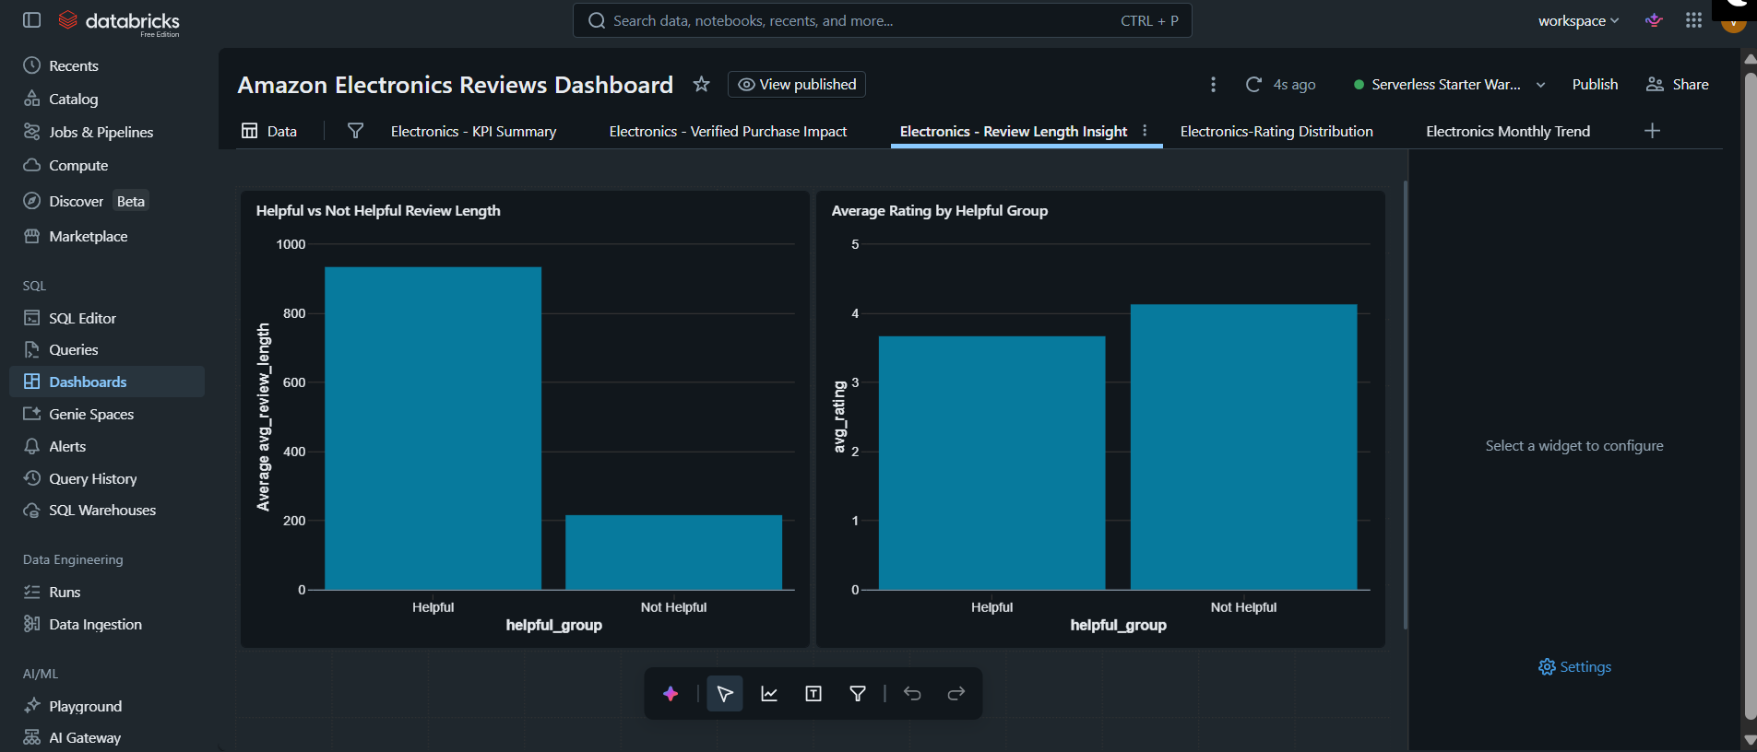

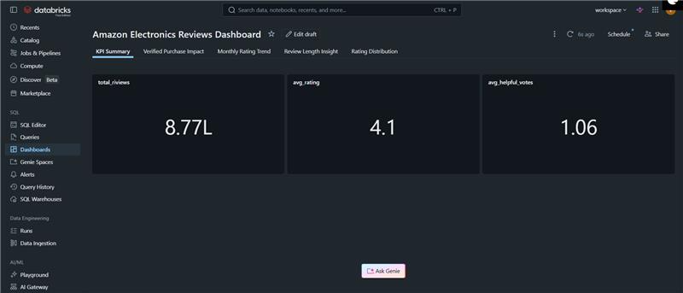

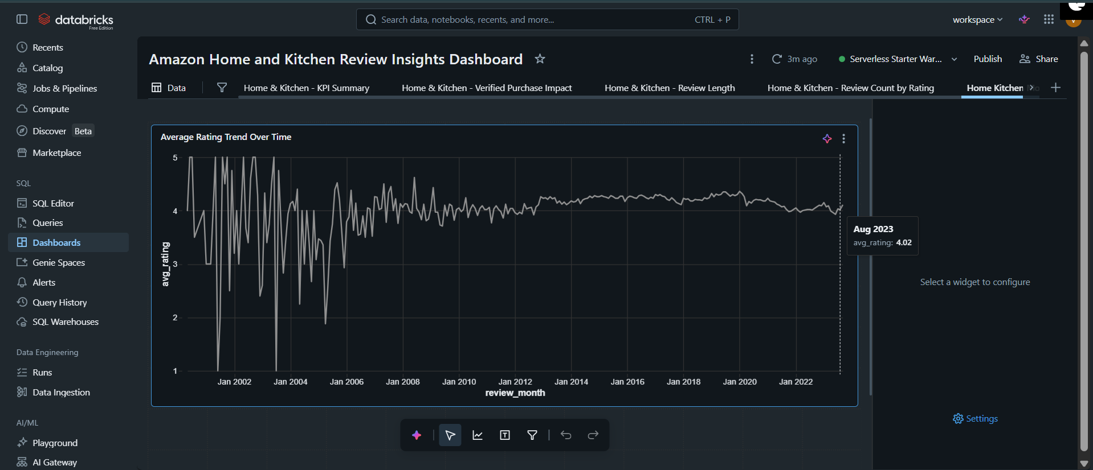

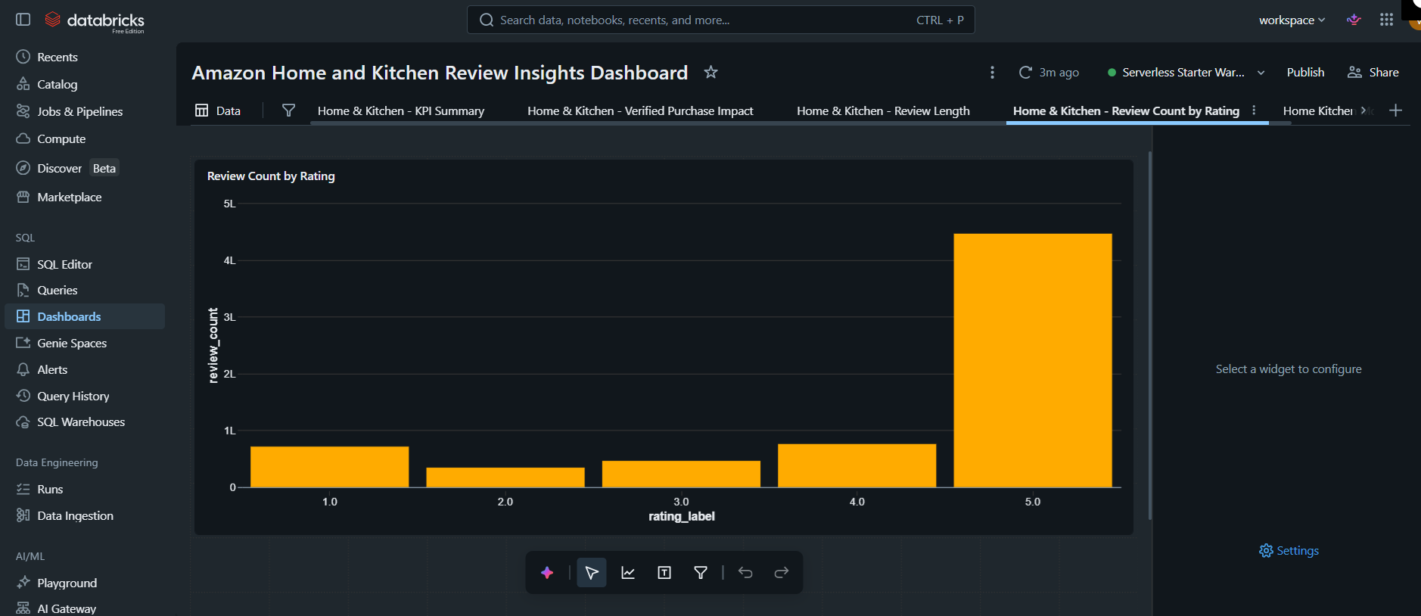

Analysis and Findings

Influence of Verified Purchase Status on Review Helpfulness
My analysis showed that verified purchase status has a significant positive influence on review helpfulness. Across the product categories analyzed, verified purchase reviews consistently received more helpful votes than non-verified reviews for every rating from 1 to 5 stars.
This finding suggests that highlighting verified customer reviews can improve user trust and support better purchasing decisions.

Temporal Trends in Product Ratings
For high-volume product categories, I observed a gradual decline in average product ratings over time. For example, the Appliances category showed a steady decrease in average ratings between 2003 and 2007.
These trends may be influenced by factors such as product lifecycle, changing customer expectations, seasonal purchasing behavior, or post-launch customer experiences.

Linguistic Characteristics of Helpful Reviews
Using correlation analysis and word-frequency comparisons, I identified several linguistic features that distinguish helpful reviews from less helpful ones.
Very short reviews averaged approximately 0.2 helpful votes, while excessively long reviews showed diminishing returns. Reviews containing 200 to 600 characters consistently received the highest average number of helpful votes (greater than 1.5).
These findings indicate that customers value reviews that are concise, informative, and focused.

Conclusion
This project provided valuable hands-on experience in building an end-to-end data analytics pipeline using Databricks and Apache Spark.
One of the primary challenges I encountered was securely accessing the dataset. Since I could not read the data directly from Amazon S3 due to authorization restrictions, I implemented an alternative ingestion workflow by downloading the dataset and uploading it into Databricks Volumes. I also learned the advantages of using Databricks Volumes, including improved upload performance and the ability to handle datasets larger than the default file size limitations.
Another key aspect of this project was integrating Sentiment Analysis with traditional exploratory data analysis. Combining structured analytics with natural language processing provided deeper insights into customer opinions beyond numerical ratings alone.
Overall, this project strengthened my skills in data engineering, large-scale data processing, exploratory data analysis, sentiment analysis, and data visualization using Spark and Databricks.
As a future enhancement, I would extend this project by developing machine learning models to predict future customer sentiment, product ratings, and review helpfulness based on historical review data.

